10X Your Leads: How Chatbots Revolutionize Lead Generation
- Ritika Sankhla
- December 8, 2023
- Chatbots
0

Explore lead generation chatbots in this blog: learn about their benefits, effective strategies, best practices, and the path to e-commerce success.
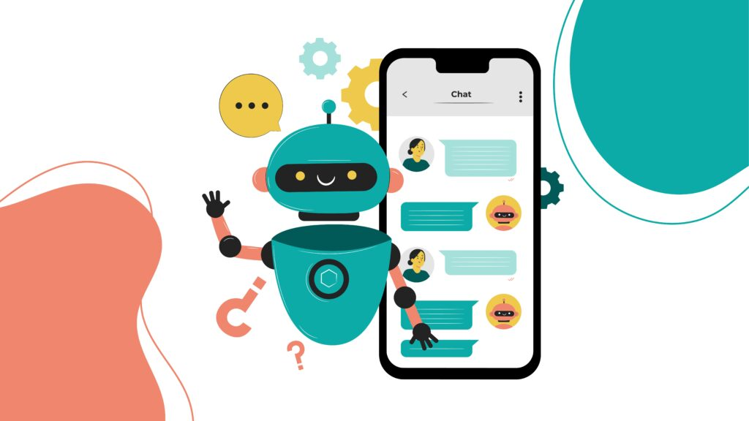
In the fast-paced digital landscape, where the success of businesses relies heavily on effective online presence and customer engagement, lead generation has become the cornerstone of growth. Among the numerous tools available, chatbots have emerged as a revolutionary force, reshaping the way businesses approach and execute lead generation strategies.
In this blog, we’ll explore the benefits of lead generation chatbots, and effective strategies, discuss best practices, and unveil the path to e-commerce success through mastering lead generation with chatbots.

Benefits of Lead Generation Chatbots:
1. 24/7 Availability and Instant Response: Chatbots, being automated, transcend the limitations of human availability. They operate round the clock, ensuring that potential leads receive instant responses, creating a sense of engagement and satisfaction. This constant availability is particularly crucial in a global market where time zones differ.
2. Personalized User Experience: Leveraging machine learning algorithms, chatbots analyze user interactions and tailor responses based on individual preferences. This personalization not only enhances the user experience but also increases the likelihood of converting leads into customers. Tailored interactions create a sense of connection and relevance, fostering trust.
3. Cost-Efficiency: Automated lead generation through chatbots significantly reduces operational costs. Unlike human agents, chatbots can handle multiple conversations simultaneously, making them a cost-effective solution for businesses of all sizes. This efficiency ensures that resources are utilized optimally, maximizing the return on investment.
4. Data Collection and Analysis: Chatbots seamlessly collect and analyze user data, providing valuable insights into customer behaviour and preferences. This data-driven approach empowers businesses to refine their lead-generation strategies and optimize conversion rates. By understanding the nuances of user behaviour, businesses can tailor their approach to better meet the needs of their audience.
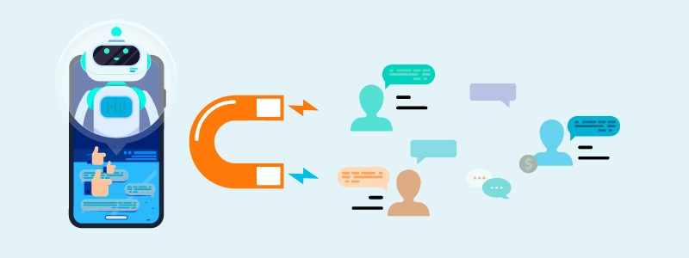

Chatbot Lead Generation Strategies:
1. Interactive Landing Pages: Incorporating chatbots into landing pages creates an immediate point of engagement for visitors. A well-designed chatbot can capture visitor information and guide them through the sales funnel, converting casual browsers into potential leads. Interactive landing pages provide a dynamic and personalized introduction to the brand.
2. Social Media Integration: Extend the reach of your chatbots by integrating them into social media platforms. Automated responses and interactive conversations on social media not only attract potential leads but also foster a sense of community around your brand. Social media integration enables businesses to tap into the vast audience present on these platforms.
3. Qualifying Leads in Real-Time: Implementing chatbots to pre-qualify leads in real-time is a strategic approach. By asking relevant questions and analyzing responses, chatbots can categorize leads based on their level of interest and readiness to make a purchase. This ensures that sales teams can prioritize leads that are more likely to convert.
4. Multi-Channel Engagement: Deploying chatbots across various channels, including websites, mobile apps, and messaging platforms, ensures that businesses can capture leads wherever their target audience is active. This omnichannel approach provides a cohesive and seamless experience for users, regardless of the platform they choose to engage with.

Best Practices for Using Lead Generation Chatbots:
1. Clear and Concise Communication: Crafting chatbot responses that are clear, concise, and aligned with the brand voice is crucial. Avoiding jargon and ensuring that communication is easy to understand creates a positive user experience. Clarity in communication helps users navigate the interaction smoothly.
2. Human-Agent Handoff: Integrating a human-agent handoff feature for complex queries or situations that require a personal touch is essential. This ensures that leads receive the attention they need while maintaining the efficiency of automated interactions. Striking a balance between automation and human touch is key to building trust.
3. Continuous Optimization: Regularly analyzing chatbot performance and user feedback is critical for continuous optimization. Using this data to fine-tune chatbot responses and improve its ability to capture leads effectively ensures that the chatbot remains adaptive to changing user behaviors and market dynamics.
4. Compliance with Data Privacy Regulations: Prioritizing data privacy and ensuring that chatbots comply with relevant regulations builds trust with potential leads. Clearly communicating how user data will be used and stored fosters transparency and assures users that their information is handled responsibly.

Mastering Lead Generation with Chatbots
1. Streamlined Customer Journey: Chatbots play a pivotal role in guiding users through a seamless customer journey. From the initial interaction to the final purchase, chatbots use their understanding of customer needs and preferences to streamline the path to conversion. This ensures a positive and efficient experience for potential customers.
2. Real-Time Analytics for Continuous Improvement: The data collected by chatbots provides real-time analytics that can be used to continually refine lead generation strategies. This iterative process ensures that businesses stay agile and responsive to changing market dynamics. By harnessing the power of data, businesses can make informed decisions and stay ahead of the competition.
3. Building Lasting Customer Relationships: Beyond lead generation, chatbots contribute to building lasting customer relationships. Automated follow-ups, personalized recommendations, and timely assistance create a positive and memorable experience for customers. Fostering loyalty and repeat business, chatbots become an integral part of the overall customer lifecycle.
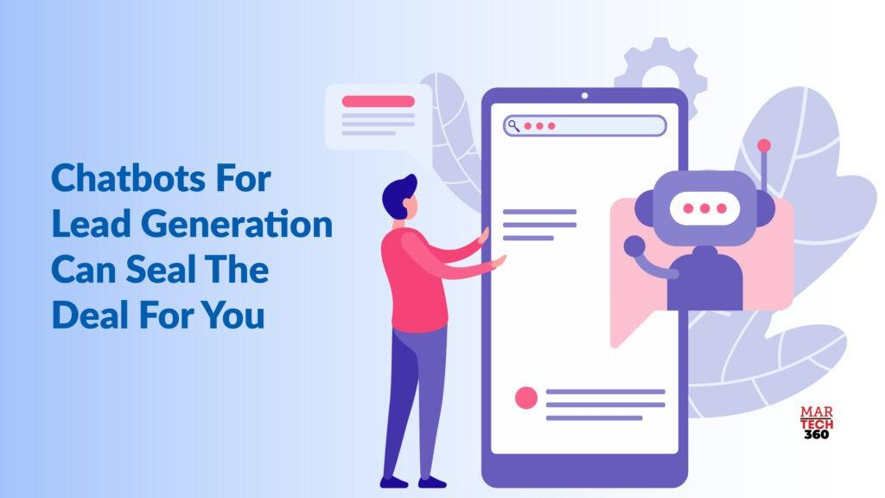

Conclusion:
In the ever-evolving landscape of e-commerce, mastering lead generation is essential for sustained growth. Chatbots, with their ability to provide instant responses, personalized experiences, and cost-efficient solutions, have proven to be a game-changer in this regard.
By embracing the benefits, implementing effective strategies, and following best practices, businesses can not only revolutionize lead generation but also pave the way to e-commerce success in the digital era. As technology continues to advance, the synergy between chatbots and lead generation will likely become even more integral to the success of businesses across industries.

